Materials to learn from
- youtube - TechWorld with Nana – 4h Kubernetes beginner tutorial.

Concepts

Node
Node is a single computer in Kubernetes cluster (a group of nodes).

Pod
Smallest unit in Kubernetes. It is an abstraction of a container. Inside of a Pod we have a container running with app, and that Pod is running on one of the nodes.
We don’t work with the container itself, just with a Pod.

Manifests
Manifests are conifguration files (mainly YAML) which defines what resources we want to create in Kubernetes cluster.
Common resources, which are also explained in more detail in further sections of this documentation are:
- Services
- Ingress
- ConfigMap
- Secret
- Volumes
- Deployment
- StatefulSet

Service
Service is a resource which we can assign to a Pod and it provides a static IP address to Pod s. Pods have its own IP address, which can change over time, and Service has a separate, static IP address and it is independent on the IP address of the Pod.
It also acts as a load balancer. We can have two replicas (described in the next section) of the same app, both attached to the same service, and service will redirect a request to the replica which is the least busy.

Replicas
We can have multiple replicas of the same app (Pod). That means that we have multiple copies of the same app running. It is useful because when one app goes down, then the other one can take its place in handling requests.
We can use a Service (described in the previous section) to create a static IP address, and each request made to that IP address will be redirected by a Service to a replica which is the least busy.

Ingress
Ingress is a resource which we can use to specify which URL will be redirecting to which Service when making a HTTP request.

ConfigMap
ConfigMap is a resource which we can use to provide an external configuration for an application running as a container in a Pod.
We can define there variables which will be used by our app running in Pod, and we can change them without changing the app itself.

Secret
Secret is a resource like ConfigMap but for storing confidential data.

Volumes
Volumes are a resource which works like volumes in Docker. Volumes allow us to save data from a container outside of a container (on a server running a container). So container will be using this data and even after container restart, that data will be still accessible.
Volumes need to be used together with VolumeMounts which will specify the path in the container where data from a Volume will be accessible.
We can additionally use the hostPath parameter to specify where data from a Volume will be stored on a server running Kubernetes.
For example we might use Volumes in a YAML manifest in this way:
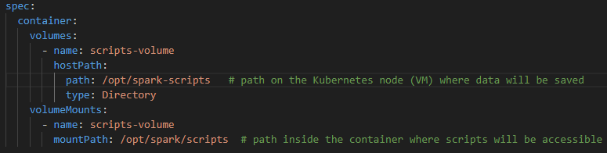
The other way of doing this is to create a separate Volume resource. Here is an example of Persistent Volume (it preserves data even after Pod is deleted):
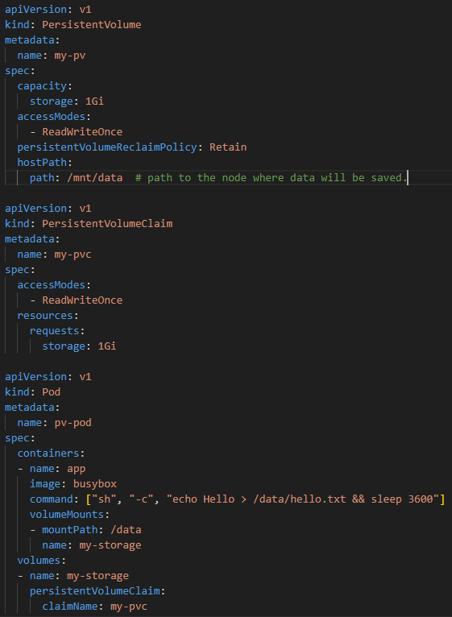
And yet another option is that we don’t create a Volume resource on our own, we just create a volume claim (PersistentVolumeClaim) and it will create a volume resource automatically:
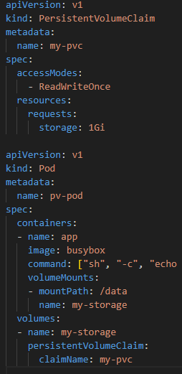

Deployment
It is a resource which we create using a manifest. It is a blueprint, set of instructions for app Pods. It is abstraction of Pods. It specifies which app we want to run (which container), how many replicas of that Pod to create and more.

StatefulSet
It is a resource which we create using a manifest. Is like a Deployment but specifically designed for applications which have a state. For example databases have a state which is their data.
Even if we are using volumes for our databases running in Pods, then still we should use the StatefulSet for them to guarantee data consistency.

Processes runnin on worker nodes
Each worker node needs to have installed 3 tools:
- Container runtime
- Kubelet
- Kube proxy

Container runtime
Each node needs to have installed a container runtime, like docker or containerd, which will be running containers.

Kubelet
It is a process running containers on nodes. It interacts with a container and node. It creates containers based on provided configuration, like Deployment.

Kube proxy
It forwards requests from Services to Pods.

Processes running on master nodes
Each master node needs to have 4 processes running:
- API server
- Scheduler
- Controller manager

API server
Users interacting with Kubernetes cluster are using the API server. It takes requests from users about what they want to do with a cluster, and then API server talks to other processes running on Kubernetes.
It is also used for authentication.

Scheduler
API server talks to the Scheduler and Scheduler decides on which node to run requested Pods. It check how much resources (CPU, RAM) will be needed for running a Pod, and which nodes have those resources available.
Scheduler doesn’t run the app itself but it talks to the kubelet and kubelet runs an app.

Controller manager
It monitors the state of Pods, if they are running correctly or if they have died. If a Pod died then Controller manager talks to the Scheduler in order to rerun a Pod.

Etcd
Etcd Stores data about all the changes that happens in a Kubernetes cluster, for example when Pod dies, and when a new Pod gets created.
It provides data used by other servicer (API server, Scheduler, Controller manager).

Kubectl
This is a tool for users to interact with a Kubernetes cluster. It allows for example to get list of Pods, create, update or delete resources.

Namespace
Namespaces are a way for organizing resources in Kubernetes. They are a groups containing specified resources (different containers running different apps).
They don’t have separate resources (nodes, CPU, RAM). They share common, cluster’s resources. They just provide a way yo logically group resources.

Helm
Helm is a package manager for Kubernetes that helps you define, install, and manage Kubernetes applications.

Sharing Helm charts
Helm uses charts, which are packages of pre-configured Kubernetes resources written in YAML. They can be uploaded and downloaded from repositories.

Templating YAML files
Helm also allows for creating YAML files which are using variables and we can put different values into them.

Debugging
Here are usefull tools for debugging.
- crictl ps -a – list the running and stopped containers.
- Crictl logs <containerID> - check logs for a given container
- ss -tuln | grep 6443 – check processes listening on the 6443 port
- ps aux | grep kube-apiserver – check processes in which the ‘kube-apiserver’ string appears.
- journalctl -u kubelet -f – view logs from the kubelet process
- kubectl get pods -n kube-system – Check pods in the kube-system namespace
- telnet 10.0.1.4 6443 – try to connect over TCP to the server with the 10.0.1.4 IP address over the 6443 port.

